
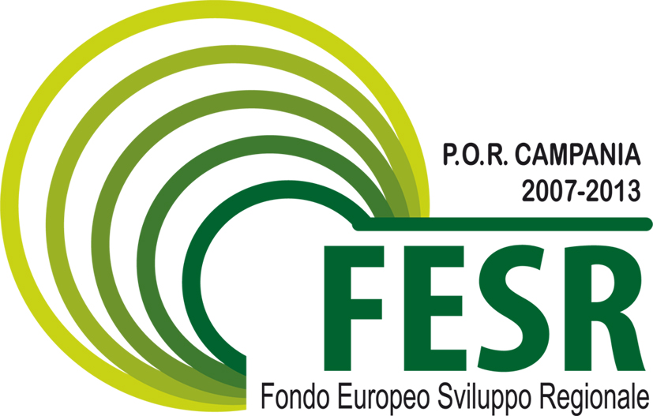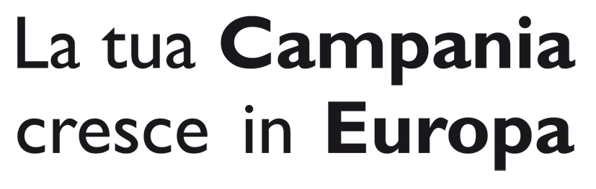

Università degli Studi di Napoli
“PARTHENOPE”
Centro d’Ateneo per l’erogazione dei servizi linguistici

proJect “lingue in festa: napulang”
Misura PO FESR 2007-2013 Asse 1 – Obiettivo operativo 1.10 “La Cultura come risorsa”

Annex B

CALL FOR THEATRE PROJECTS

To the “Centro d’Ateneo per
l’erogazione dei Servizi Linguistici”
University of Naples “Parthenope”
Via Petrarca, 80
80122 NAPOLI

APPLICATION FORM

The undersigned (Surname and Name) _______________________________________________

National Insurance Number _________________________________________ Sex M / F

Place of birth ________________________Date of birth______________________________

Residence ______________________________________

Residence address_________________________ City/Town _____________ Postcode_____________

Telephone_________________Mobile:________________Fax________________

E-mail (required)______________________________________________________________

Aware that false or forged declaration will be punished according to the Italian Penal Code (art. 76 DPR, 28 December 2000 n. 445), the undersigned, responsible and representative of the student University group __________________________________ University ____________________of ________________________________________________________________________________
ASKS

to take part in the selection for plays to be staged during “Lingue in Festa: Napulang”, organized by the University of Naples “Parthenope” within “Misura PO FESR 2007-2013 Asse 1 – Obiettivo operativo 1.10 attività A) “La Cultura come risorsa”, with the following play:

Section I am applying for :
□ Foreign Section
□ Italian Section

Title of the work _________________________________________________________

Language proposed for the performance ____________________________________________

The undersigned declares that:
- the submitted text is □original □ adaptation of theatre piece or novels or poems;
- the group consists of n. ________ elements of which n.__________ university students, n. __________ senior year university students. _____________ of which n. ________ with disability ;
- to have read and to accept all the conditions of the competition;
- to enclose the following documents:
- - a hard copy and a digital copy for each language of the original text composed for the selection, together with the declaration of conformity for both copies;
- - a project summary, in Italian, containing:
- a) an abstract of the work of about 1000 typed characters (200 words circa);
- b) the number of actors;
- c) direction notes;
- d) a data sheet of the work, written in Italian, listing the kind of costumes, sizes and furniture as well as lights, music and technical equipment necessary to stage the play, together with a detailed budget in euro;
- e) sketches of the set with the number of the scenes and the list of the necessary items of furniture;
- - a promotional video on CD or DVD not exceeding the duration of 10 minutes (optional);
- - signed CV of each member of the group, written in both English and Italian;
- - a validated education certificate for each member of the group;
- - a valid I.D. (preferably passport).

Please send all communication and information at the following address:

(every change of address shall be communicated )

Address_____________________________City / Town _________________________________

Postal Code ________________________Telephone ____________Mobile ________________

e-mail (required)_______________________________________________________________

Date ___/___/______ Signature

_____________________

Note:
False and forged declarations in acts and documents will be punished according to the Italian Penal Code (art. 76, DPR n. 445 of 28/12/2000).
False or forged declarations nullify the benefits derived from the selection procedure (art. 76, D.P.R. n. 445 of 28/12/2000).
In compliance with the provisions of Dlgs. 196/2003
Personal data will be used and treated exclusively for the selection process and for institutional reasons. The University of Naples “Parthenope“ is responsible for the treatment of personal data. The interested person can claim his/her right according to artt. 7, 8 9 and 10 of Dlgs n. 196/2003.

Non-EU citizens shall present a valid passport or an equivalent document in conformity with the immigration laws.

Signiture
________________________

